Graduate Intern Report – Diabetes detection using Machine Learning

In this 12-week internship project, we aim to develop a machine learning (ML) model to accurately predict Type 2 diabetes (T2D), with a primary focus on dietary predictors. In other words, we seek to identify which dietary components or combinations thereof are most strongly associated with the risk of developing T2D. The project will also involve the consideration of potential confounding variables to ensure robust and reliable predictions. The dataset to be used is the National Diet and Nutrition Survey (NDNS) [1] covering the years 2008–2020, including adults aged 18 and over, with data from approximately 8,000 participants.
A Machine Learning (ML) pipeline is a structured sequence of steps used to automate and streamline the end-to-end process of developing, training, validating, and deploying a ML model. We follow bellow key stages of ML pipeline:
- Data Collection
  - Gather raw data from various sources (e.g., databases, APIs, sensors).
  - Example: CSV files, SQL databases, web scraping.
- Data Preprocessing
  - Cleaning: Handle missing values, outliers, duplicates.
  - Transformation: Scaling, normalisation, encoding categorical variables.
  - Splitting: Train-test (and optionally validation) split.
- Feature Engineering
  - Selection: Choose relevant features.
  - Extraction: Create new features from raw data (e.g., text vectorisation, combining features).
  - Dimensionality Reduction: PCA, feature importance pruning.
- Model Selection
  - Choose an appropriate algorithm (e.g., Decision Tree, Random Forest, SVM, Neural Network).
  - Use baseline models for comparison.
- Performance Metric
  - How to measure the performance of each model.
- Model Training
  - Fit the model to training data.
  - Tune hyperparameters (grid search, random search, Bayesian optimisation).
- Model Evaluation
  - Evaluate performance using metrics (e.g., accuracy, precision, recall, F1-score, AUC for classification tasks).
  - Use test set (or cross-validation) for reliable results.
- Model Deployment
  - Deploy the trained model to a production environment.
  - Serve via APIs, integrate with applications or dashboards.
- Monitoring & Maintenance
  - Monitor model performance over time (e.g., concept drift, data drift).
  - Retrain or update model as needed.

Figure 1 – Pie chart showing the distribution of diabetic data in the raw dataset 4
Figure 3 - Pie chart showing the distribution of diabetic data in the processed dataset 5
Figure 5 - Pie chart showing the divide in the number of days the survey took in the processed dataset 7
Figure 6 - Frequency chart for the age range in the processed dataset 8
Figure 7 - Pie chart showing the split of males and females in the processed dataset 9
Figure 8 – Chart comparing diabetes distribution of males and females in processed dataset 10
Figure 9 - Pie chart showing the ethnicities in the processed dataset 11
Figure 11 - Pie chart showing the number of entries from each country in the processed dataset 12
Figure 12 - Frequency table showing the glucose levels of patients in the processed dataset 13
Figure 14 - Graph showing the count of each entry for general health in the processed dataset 14
Figure 15 - Pie chart showing the number of entries that have eaten 5 or more fruit or vegetables per day in the processed dataset 15
Figure 16 - Proposed architecture of our ML process 17
Figure 17 - KNN Confusion Matrix with an oversampling ratio of 40% and parameters set to: 'n_neighbors'= 29 23
Figure 18 - DT Confusion matrix with an oversampling ratio of 40% and parameters set to: 'max_depth'= 23, 'max_features'= 24 24
Figure 19- RF Confusion matrix with an oversampling ratio of 40% and parameters set to: 'max_depth'= 19, 'max_features'= 2, 'n_estimators'= 8 24
Figure 20 – Bar chart showing model performance using oversampling ratio of 40% truncated to show 0.8 and higher. 25
Figure 21 - Area under curve diagram 26
Figure 22 - Graph of feature importance showing all the features of the model 27
Figure 23 - Graph of feature importance with the top 15 dietary features. 27

Equation 1- Accuracy 21
Equation 2 - Precision 21
Equation 3 - Recall 21
Equation 4 - F1-score 22

Table 1 - Table showing the count of each category of T2D in the raw dataset 4
Table 2 - Table showing the count of each category of T2D in the processed dataset 5
Table 3 - Table showing the number of entries from each country in the processed dataset 9
Table 4 - Table showing the general health of the patients in the processed dataset 11
Table 5 - Random oversampling exploration with the random forest model using the processed dataset 15
Table 6 - Table of tuned parameters for the ML models 18
Table 7 - LIME results on positive diabetic prediction using random forest model with 40% oversampling ratio 26
Table 8 - LIME results on positive diabetic prediction using random forest model with 40% oversampling ratio 27

Literature Review
Paper ID | Year of Publication | Dataset size | Dataset source | Binary classification | ML model | Best Model | Performance metric | Num of features | Dietary Data
[2] | 2024 | 450,000 | UK Biobank | YES | Xgboost( gradient boosting), | Xgboost | ROC AUC | 10 | NO
[3] | 2022 | 9,858 | National Health and Nutrition Examination Survey, 2009-2010 and 2011-2012. | YES | MLR,LR,NB,J48,MLP,RF | RF | ACC,SE,FM,AUC | 14 | NO
[4] | 2022 | 1,552 | "survey and google forms from different geographical regions." | YES | KNN,LR,SVM,NB,DT,RF,GB | GB | Accuracy, precision, f1-score,ROC | 11 | YES
[5] | 2021 | 286 | Pima Indian | NO | Logistical regression, classifier tree (decision tree) | Logistical Regression | accuracy | 5 | NO
[6] | 2021 | 100,000 | National Institute of Diabetes and Digestive and Kidney Diseases | YES | logestic regression, decision tree, support vector machine, xgboost, random forest and adaboost | Adaboost | accuracy, F1-score, recall, precision and AUC | 55 | NO
[7] | 2020 | 768 | Pima Indian diabetes dataset | YES | KNN, DT, NB, SVM, LR, RF | RF | Precision, Recall, F1-score | 9 | NO
[8] | 2025 | 2669 | Henan Rural Cohort Study | NO | LR,SVM,RF,XGB | XGBoost | Accuracy, specificity, precision, recall, and F1 score | 32 | YES

Data Collection

The NDNS dataset
This data was sourced from the NDNS (National Diet and Nutrition Survey) [1] which is a continuous survey of the public's health across the UK that began recording data in 2008 and is still collecting data today. The level of fibre that an individual has consumed has been calculated using the methods provided by the AOAC.
This dataset contains 52 features about the information about of 8348 individuals related to their health and diet. All features can be broken down into 3 categories, patient background (age, sex, ethnicity…), patient health (Waist, BMI, GenHelf,..) and the patient diet (Proteing, Fatg, totalFruit,...).
The label for this dataset is T2D and if the individual has been diagnosed or not. The possible values are split with 1 being non-diabetic and 2 being diabetic. This dataset only includes T2D as this is the type that an individual can develop due to their lifestyle.

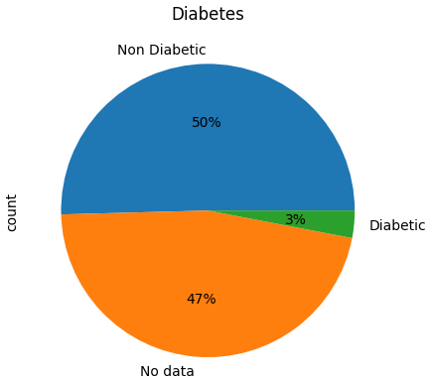
Figure 1 – Pie chart showing the distribution of diabetic data in the raw dataset
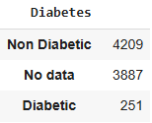
Table 1 - Table showing the count of each category of T2D in the raw dataset
As seen in the Figure 1, most of the entries in the raw dataset are of individuals without T2D or there isn’t recorded data on whether they have T2D or not. This imbalance will have a large impact on how we handle the data when it comes to processing and predictions.

To address this issue, we removed the entries that contained no diabetic data leaving 4460 entries with this descriptor. This will be expanded upon in the pre-processing section but it’s important to note this change to the data as it will be the basis for all analysis from this point on.

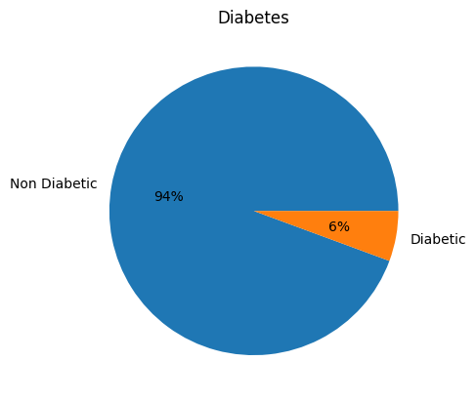
Figure 2 - Pie chart showing the distribution of diabetic data in the processed dataset

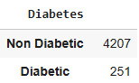
Table 2 - Table showing the count of each category of T2D in the processed dataset

PROCESSING THE DATASET

In this section, all the features will be given a brief description and context about what they are showing and how they are related to the other features in the dataset.
Patient Background Features

SurveyYear : This feature relates to when the survey was taken. The NDNS counts from the first year it was taken in 2008 so that would be year 1 and the range of this dataset goes to 2019 which would be year 11. This feature is important if we want to track the trends in the health of individuals and see whether T2D levels are rising or decreasing.

Ndays : Number of Diary days. This is how long the individual was keeping a record for. Most of the entries are 4 days long but there are 53 individuals who recorded for 3 days. This duration of days means that the individual's diet is more likely to be consistent with their usual diet and give more accurate results. In Figure 3 we see that almost all the records are taken over the 4-day period.

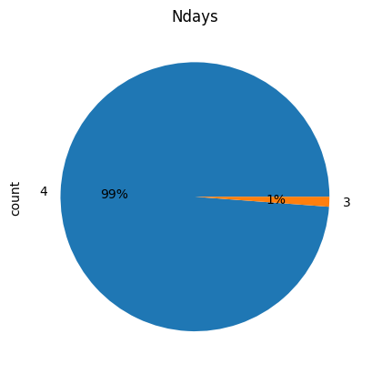
Figure 3 - Pie chart showing the divide in the number of days the survey took in the processed dataset

Age: This feature is the age of the individual; in this dataset it ranges from 18 to 96 and is stored as an integer. The age feature is important because age affects the likelihood of an individual developing T2D.

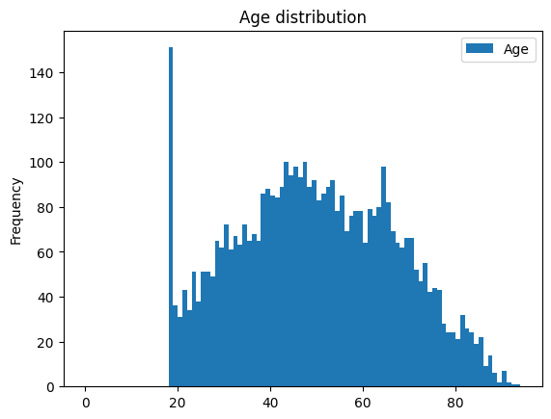
Figure 4 - Frequency chart for the age range in the processed dataset
By a significant margin, 18-year-olds have the largest amount of the entries in the dataset with 151 entries, the second largest was 43-year-olds with 100. From Figure 6 we can see that, aside from the large number of 18-year-olds, there is an increase with middle aged people.

Sex: The sex of the individual is recorded as an integer in this feature; the recorded values are 1 if the individual is male and 2 if they are female. The distribution of sexes in the dataset is split with 59% female and 41% male.

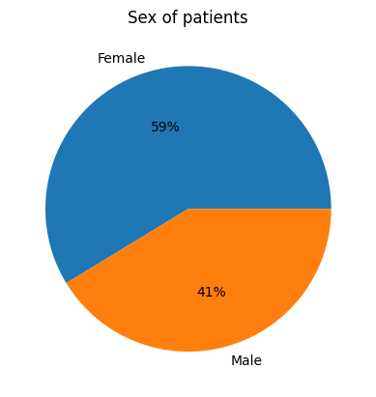
Figure 5 - Pie chart showing the split of males and females in the processed dataset
If we compare the occurrences of T2D in females and males, we can see that despite this imbalance in the sexes there is a similar amount of male and female that tested positive for T2D. As the positive T2D class is smaller it’s good that their similar amounts as when we use it for training, its less likely to biased against one of the sexes.
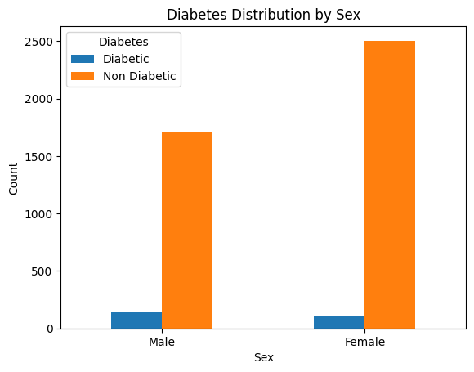
Figure 6 – Chart comparing diabetes distribution of males and females in processed dataset

Ethgr5: This feature is the classification of what ethnicity the individual is split into 5 groups. These groups are White, Mixed ethnic group, Black or Black British, Asian or Asian British and last any other group.

Ethgr2: Like Ethgr5, this feature is based on the ethnicity of the individual except this feature condenses it. The two values that it can be are 1 for White and 2 for Non-White. This feature is stored as a float. This is relevant for the same reason as Ethgr5 but for a more generalised result. The likelihood of a non-white individual in the UK developing T2D is higher than it is for white individuals in the UK (Goff, 2019) [9] so using this data can provide better results for the models.
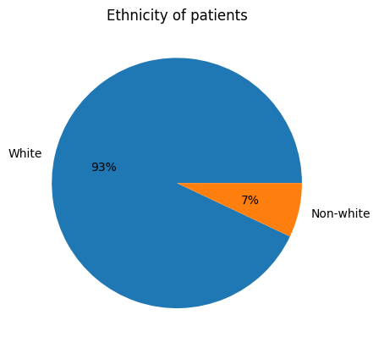
Figure 7 - Pie chart showing the ethnicities in the processed dataset

Country: This feature refers to where in the UK the individual is from. This can be England, Scotland, Wales, Northan Ireland and NI. What country an individual is from can have an impact on their dietary habits due to availability of food types and lifestyle but in this case the differences between the countries in the UK isn't different enough. The NI stands for National Identity and used by people who are both identify with both British and Irish Citizenship.

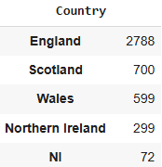
Table 3 - Table showing the number of entries from each country in the processed dataset

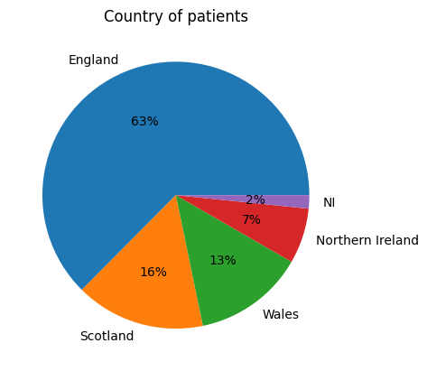
Figure 8 - Pie chart showing the number of entries from each country in the processed dataset
Most of the entries are from England with the rest of the entries being somewhat evenly split between the rest of the country.

Patient Health Features
BMI: This feature tells us the Body Mass Index of the individual; this value is derived from the weight and height of the individual. The range of this value is 40 in this dataset with the smallest being 13 and the largest being 53.

Waist: This feature is the size of the individual's waist. There are 109 entries with invalid waist data points which could be cause by several reasons such as the individual refused to take the waist measurement, they were unable to take the measurement, or they could have been pregnant. These entries aren’t an error so should be included in the process.

Glucose: This feature is the glucose levels of the individual in mmol/L and stored as a float. High blood glucose levels can mean that the individual has prediabetes which means that they are at higher risk of getting T2D in the future.
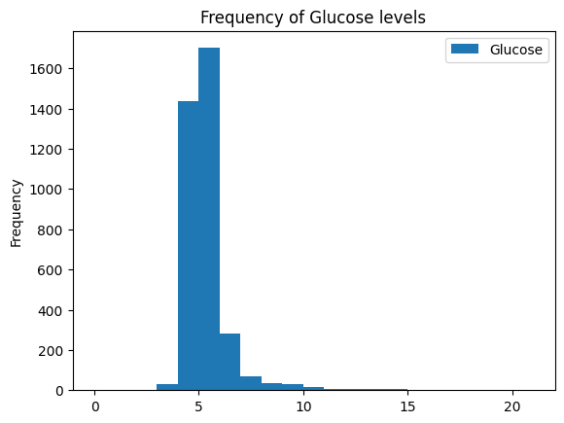
Figure 9 - Frequency table showing the glucose levels of patients in the processed dataset
From the graph above we can see that there isn’t a lot of variation in the glucose levels with most of the readings being at or around 5 mmol.

HbA1C: This feature is the average blood glucose levels of the individual over the last 2 or 3 months. For diabetics, the ideal level of HbA1C should be 48 mmol/mol or below. This is a similar feature to the glucose levels, but this is measuring how much glucose is attached to the haemoglobin and not the general glucose levels in the body.
GenHelf: This feature is a self-assessment of the individual's general health. The range is 1 to 5 with 1 being “Very good” and 5 being “Very bad”. This datapoint comes from the individual so might not be an accurate value but could still be an indication of other issues with the individual.
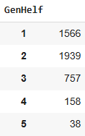
Table 4 - Table showing the general health of the patients in the processed dataset

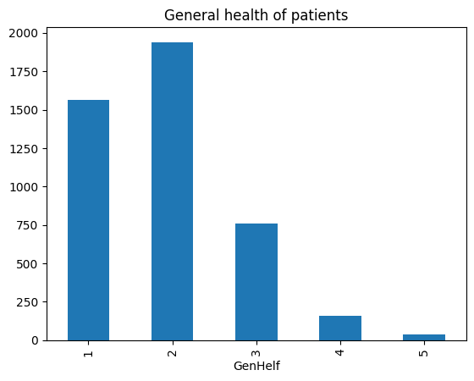
Figure 10 - Graph showing the count of each entry for general health in the processed dataset
Most of the individuals place themselves in the 1 or 2 categories meaning they think they are in good health. This is good data to get an insight into whether individuals own perspective on their health correlates to their actual health.
Patient Diet Features
This next section is comprised of the features related to the diet of the individual. The features are separated into food types and the data recorded is the amount as a float variable. Each feature is for a specific aspect of the diet and was recorded over 3-4 days.

Achieve5: This is whether the individual eats five or more portions of fruit and vegetables a day. This is stored as a float with 1 being yes and 2 being no. The data is derived from other data recorded in their diaries.

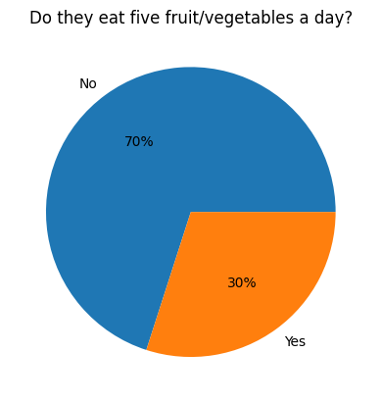
Figure 11 - Pie chart showing the number of entries that have eaten 5 or more fruit or vegetables per day in the processed dataset

70% of the individuals who were surveyed didn't meet the 5 pieces of fruit and vegetables a day quota. We believe that this value could be misleading as they could still consume a healthy amount of fruit and vegetables without meeting the quota, but it does give us a good sense of their eating habits.

AOACFibreg: This feature refers to the amount of dietary fibre an individual has consumed in grams using methods standardised by the Association of Official Analytical Chemists. 30g of Fiber is considered the goal and is a sign of healthy eating.
Energykcal: Energy (kcal/portion)
FoodEkcal: Food energy (kcal) diet only
Proteing: Protein (g/portion)
Fatg: Fat (g/portion)
Saturatedfattyacidsg: Saturated fatty acids (g/portion)
Carbohydrateg: Carbohydrate (g/portion)
Totalsugarsg: Total sugars (g/portion)
Starchg: Starch (g/portion)
FreeSugarsg: Free sugars (g/portion)
FatpctotE: Fat percent total energy
FatpcfoodE: Fat percent food energy
CHOpcfoodE: Carbohydrate percent food energy
CHOpctotE: Carbohydrate percent total energy
SFApcfoodE: Saturated fatty acids percent food energy
SFApctotE: Saturated fatty acids percent total energy
TotalsugarspcfoodE: Total sugars percent food energy
TotalsugarspctotE: Total sugars percent total energy
FreeSugarspcfoodE: Free sugars percent food energy
FreeSugarspctotE: Free sugars percent total energy
WHOLEMEALBREAD: Wholemeal bread (g)
SOFTDRINKSLOWCALORIE: Soft drinks low calorie (g)
SOFTDRINKSNOTLOWCALORIE: Soft drinks not low calorie (g)
SUGARCONFECTIONERY: Sugar confectionery (g)
FRUIT: Fruit (g)
NUTSANDSEEDS: Nuts and seeds (g)
PASTARICEANDOTHERCEREALS: Pasta, rice and other cereals (g)
SALADANDOTHERRAWVEGETABLES: Salad and other raw vegetables (g)
WHITEBREAD: White bread (g)
Beansg: Beans and pulses (incl from composite dishes) (g)
Totalfruit: Total fruit (not including juice)
Totalveg: Total vegetables
Totalfruitandveg: Total fruit (not including juice) and vegetables
Fruitvegportions: Portions of fruit and vegetables (80g)
Totfruitvegportions: 5 - a -day portions (portions/day)
ProcessedRedMeatg: Processed red meat (including from composite dishes) (g/portion)
Totalredmeat: Total red meat (incl from composite dishes) (g)
Totalmeat: Total meat (incl from composite dishes) (g)

Proposed architecture

The process that starts with the data and ends with a trained model is shown below in figure 16. This process consists of different sections that are related to the processing and preparation of the data, the training and testing of the selected models and the validation and deployment of the trained models.
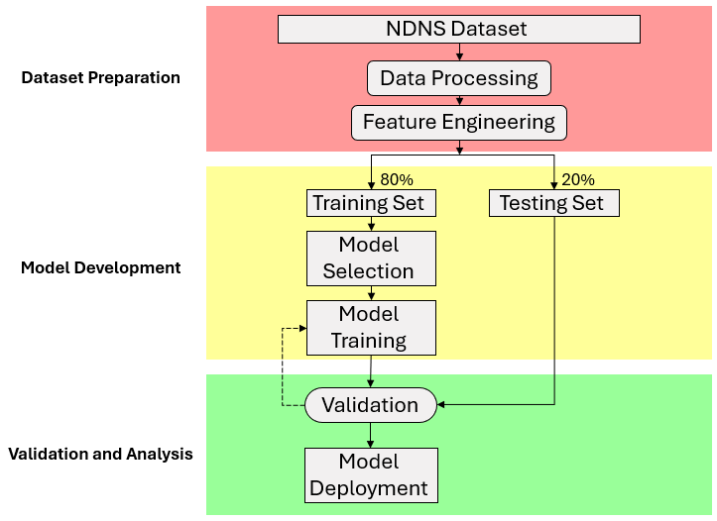
Figure 12 - Proposed architecture of our ML process

Data Preprocessing

Cleaning

The dataset is comprised of 8348 entries with 53 features. The first stage of processing that we took was to remove the entries that had missing data. The provided dataset has a substantial amount of missing or invalid data, specifically in the T2D column. This datapoint is vital as that is the label that we are training the model on, and we won’t be able to verify the results. Due to the missing data, we cannot use these entries which means that they should be removed, that leaves 4710 entries that can be used by the models.

Before we started working on the models, we evaluated each feature so that if they need to be altered, they would be so that they work best with the model.

The first modification that we made to the dataset was to remove the “seriali” column from the data. This is an identifier and has no bearing on the outcome of the model. It is also a large, randomly generated number which if not removed would result in less accurate models as the models try to find a correlation between these random numbers.

Another alteration made to the dataset was to the ‘Country’ feature. When working with ML models, the data must be formatted into numbers. The countries column stores the data on which country the individual is from as text, so we need to convert the different countries into numbers. Each country will have a corresponding number e.g. “England” is 1, “Scotland” is 2. There is no loss of information as we can still use it in the number format as we know which number is which country.

Transformation

There are many different features in the dataset and a variety of different ranges of data. The models don’t consider what type of data each feature is, they only process the number from each feature and the larger number has a bigger influence. This means that a feature with a higher range like ‘Age’ could be seen as more important as it can vary from 18 to 90+ where ‘GenHelf’ is a feature that might prove more useful, but its range is 1 to 5.

To account for this, we perform a process called normalization. Normalization is where we take the values from each feature and scale it into a decimal point number between 0 and 1. This means that each feature is judged on an equal scale and the models won’t favour certain features over others without good reason.

As show in the data collection section, most of this dataset is non-diabetic. A dataset that has a lot more data with one value than others is called unbalanced. This unbalanced dataset can lead to the models being biased towards the classes that appears the most. This can be solved by including more data on the side of the minority but as in our case we don’t have more data to work with, we must use a method called random oversampling.

Random oversampling takes a portion of the dataset and randomly selects points to duplicate them and adds them back to the dataset. This method can be performed multiple times but the data from the minority class is always chosen at random. For our dataset the target is the T2D class so by performing the oversampling multiple times we can balance the dataset. To balance the data, we tested different ratios of oversampling. As seen in table 5, we instantly see a jump in performance with an oversampling ratio of 20% and by 40% we get are getting more than 0.99 in all metrics. In higher ratios the performance increase lessens gradually so staying with the 40% oversample is best.

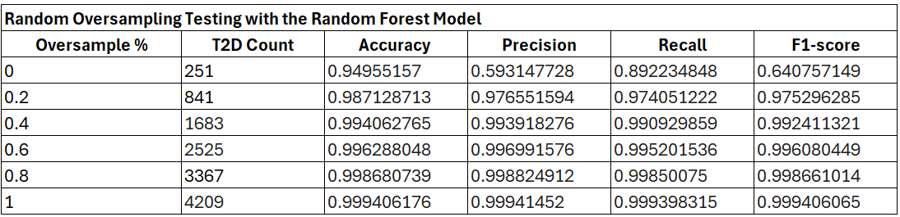
Table 5 - Random oversampling exploration with the random forest model using the processed dataset

There are other methods for dealing with unbalanced datasets like SMOTE which uses the minority class to synthesises new data till its balanced with the majority class. While there are situations where it is applicable, we are dealing with medical data that would have a large impact if there were incorrect predictions made (Gholampour, 2024) [10]. Because of this we should not use synthetic data and stay with the real data that we have.

Splitting

To assess the performance of the models, we need some data to use for testing. This cannot be any of the data that we used to train the model as we need to be sure that it can make predictions on other datapoints not just the ones it was trained on. The way we do this is by splitting the data into train and test, 80% of the data will be used to train the model and 20% will be used for testing. Using the test data to evaluate the performance of the models is useful as it’s the closest to testing with external data that we can achieve.

Processed data

After cleaning the dataset to remove the data that we can’t use, transforming it so the data we do have is more useful and splitting the data so that its used properly, we are left with 8418 rows and 50 features.

MODEL SELECTION

There are several different models that we will use for our classification task now that the data has been pre-processed.

k-Nearest Neighbour (KNN)
We started with the ‘Nearest Neighbour’ model, which works by finding similar datapoints and then making a prediction. The prediction is made using the datapoints which are closest to the new datapoint (these are called neighbours or ‘k’) and the most common out of this surrounding data determines the class label. The main aspects of the model that will influence its decisions is the number of neighbours that we want to consider and the distance from each neighbour to the new datapoint which is useful when comparing similarity to the other data.

Decision Tree (DT)
The next model that we will evaluate is decision tree classification. This model uses many conditional statements to classify its data. Then when the model is tasked with classifying a value, it follows these conditional statements till it reaches the end of a branch and a classification decision is made. Several developments can be applied to the model to potentially increase performance such as restricting the maximum depth of the tree (how many decisions it can make) or the minimum samples required to split a node.

Random Forest (RF)
The random forest model is multiple decision trees that all make a prediction. The output of random forest is selected by the class that was decided by the greatest number of trees. There are several parameters that we can change including all the parameters that we could change from the decision tree model but also some more like the number of trees. We can also adjust the random state to see if that will produce more accurate results.

PERFORMANCE METRICS

An important step is to evaluate how we are going to determine the performance of the models. This might seem simple but to do this there are multiple factors that we must consider.

One metric of performance that we produced was the accuracy of the model. This is calculated using the True positives (TP), True negatives (TN), False positives (FP) and False negatives (FN).

$$Accuracy=\frac{TP+TN}{TP+TN+FP+FN}$$
Equation 1- Accuracy

To start off, we can’t only rely on accuracy to evaluate a model. The performance of the whole model must be considered including all classes and features. For example, with our dataset we could classify all the data as non-diabetic and get an accuracy of 94% which sounds good but is fundamentally wrong for our research.

There are three other metrics that we can use to evaluate a model after running it. These are: precision, recall, f1-score.

- Precision is used to show out of all the positive predictions made, how many were true positives.
$$Precision= \frac{TP}{TP+FP}$$
Equation 2 - Precision

- Recall is used to show out of how many correctly classified true positive predictions were made from all the actual positives.

$$Recall= \frac{TP}{TP+FN}$$
Equation 3 - Recall

- F1 score is a Combination of both the precision and recall metrics, it shows how well the model handles the different data and if there is a trade off in any part. One important note is that if either of the values is zero, then the F1 score of a model falls to zero.

$$F1 Score= \frac{2×Precision×Recall}{Precision+Recall}$$
Equation 4 - F1-score

When evaluating the models the metric that we used was F1 score as it favours false positives which is what we need when dealing with medical data. A high F1 score means that it is judging all the data correctly. This result, along with the others, will be what will determine the performance of the models. When searching for the best parameters we judged them differences based on the highest F1 score.

MODEL TRAINING

The next stage is to take the pre-processed training data and apply it to the model we selected.

To find the best parameters for each model, we perform hyper-parameter tuning to determine the combination of parameters that perform the best. When tuning, as stated before, the metrics that we will be aiming for will be F1-score. Using an automated hyper-parameter tuning method called a grid search, we can find the optimum parameters.

Classifier | Tuned Parameter Values
KNN | 'n_neighbors': 29
DT | 'max_depth': 23, 'max_features': 24
RF | 'max_depth': 19, 'max_features': 2, 'n_estimators': 8
Table 6 - Table of tuned parameters for the ML models

To display the performance of each ML algorithm, we use a confusion matrix which displays how the model classified each prediction and whether it was correct or not. This helps us when determining if there is an issue with a model and where it is falling short.

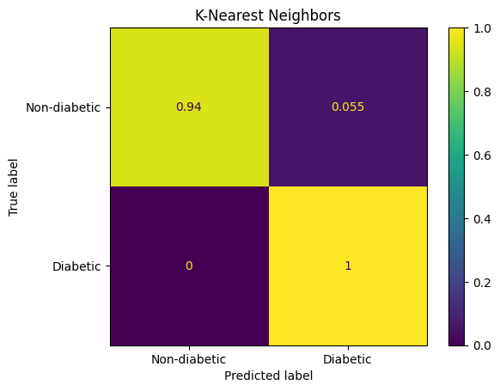
Figure 13 - KNN Confusion Matrix with an oversampling ratio of 40% and parameters set to: 'n_neighbors'= 29
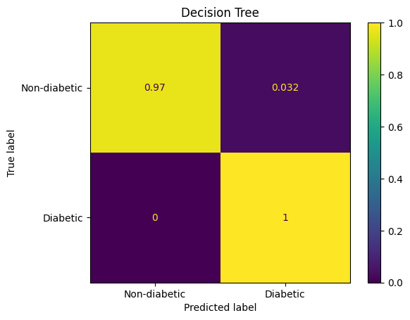
Figure 14 - DT Confusion matrix with an oversampling ratio of 40% and parameters set to: 'max_depth'= 23, 'max_features'= 24
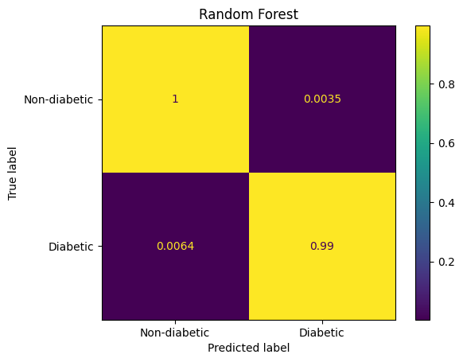
Figure 15- RF Confusion matrix with an oversampling ratio of 40% and parameters set to: 'max_depth'= 19, 'max_features'= 2, 'n_estimators'= 8

MODEL EVALUATION

For the evaluation, we used accuracy, recall, precision and F1-Score. Due to the nature of how these values were calculated, they will be similar but validating for discrepancies and seeing where each model is not performing well is vital at this stage.

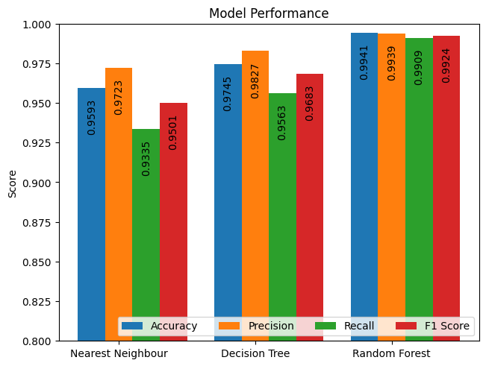
Figure 16 – Bar chart showing model performance using oversampling ratio of 40% truncated to show 0.8 and higher.

Please note that this table has been truncated to only show a score of 0.8 and higher.

The Random Forest model performed the best in all categories with an accuracy of 99.41%, precision of 99.39%, recall of 99.09% and an F1-score of 99.24%. Compared to the other models, the performance metrics of RF are more grouped together. We can now perform a more in-depth analysis of the random forest
model to determine other important details about the trained model.

We can map the true positive against the false positive rate to see the performance of the Random Forest Grid Search using a Receiver Operating Characteristic curve or ROC curve. We use these to determine the highest true positives rate against the false positives.
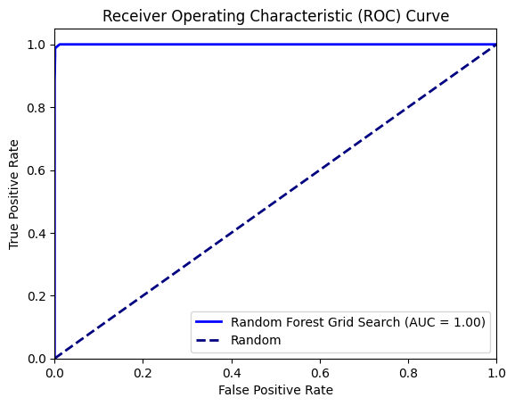
Figure 17 - Area under curve diagram

EXPLAINABLE AI

Feature Importance
The next stage is to explore how each feature of the model impacts the diagnosis made by the model. We can use the trained model and the results to see which feature contributed the most to the T2D and as seen in Figure 22.

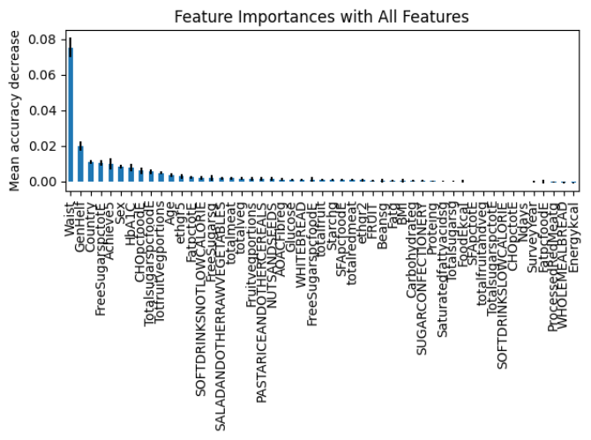
Figure 18 - Graph of feature importance showing all the features of the random forest model
For our research we want to primarily focus on the dietary data so by looking at the top 15 dietary features, we can see which had the largest influence on the decision.

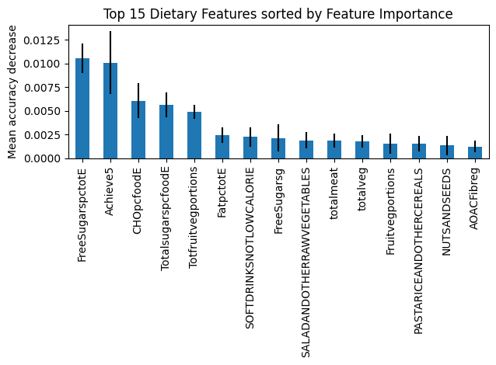

Figure 19 - Graph of feature importance with the top 15 dietary features of the random forest model.
Global SHAP
The next step is to progress with the analysis of individual features. Using SHAP, we can calculate whether a feature is going to have a positive or negative impact when diagnosing a patient and by how much. As seen in Figure 20, HbA1C and Glucose are the most important features that contribute the most to the diagnosis. The biggest dietary feature is “pasta, rice and other cereals”.

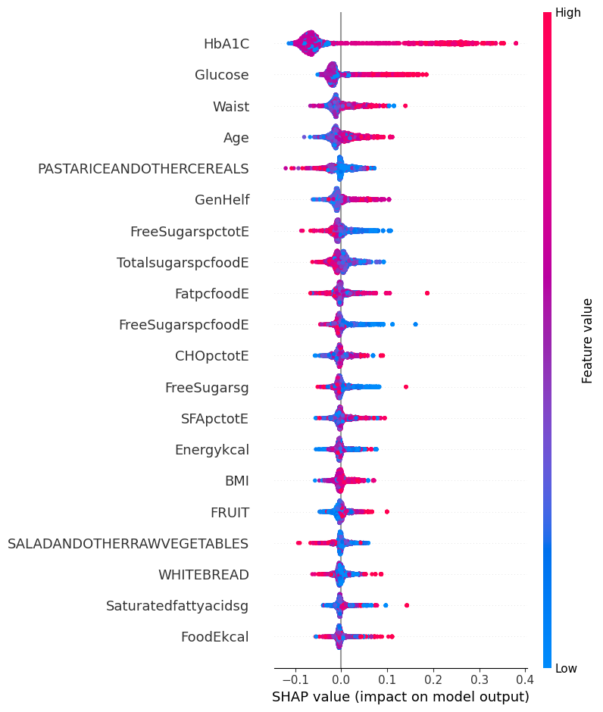
Figure 20 - Global SHAP values based on the trained random forest model at 40% oversampling ratio

Local SHAP
We can also look at the local values and see the features that impacted a specific prediction from the dataset. As expected, HbA1C is contributing the most to the diagnosis but features related to dietary data provide the next largest contribution to the prediction for both diabetic and non-diabetic patients.

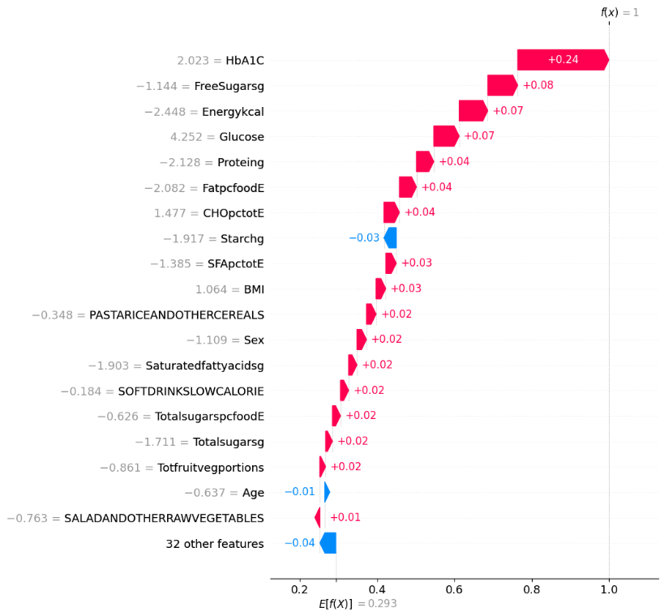
Figure 21 - Local SHAP values on negative diabetes prediction on row 4 using the random forest model at 40% oversampling ratio
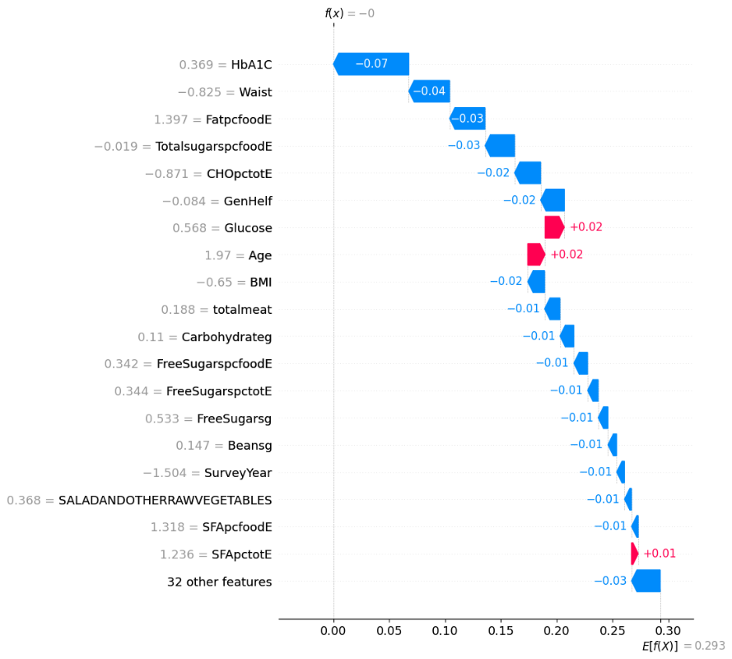
Figure 22 - Local SHAP values on negative diabetes prediction on row 3 using the random forest model at 40% oversampling ratio
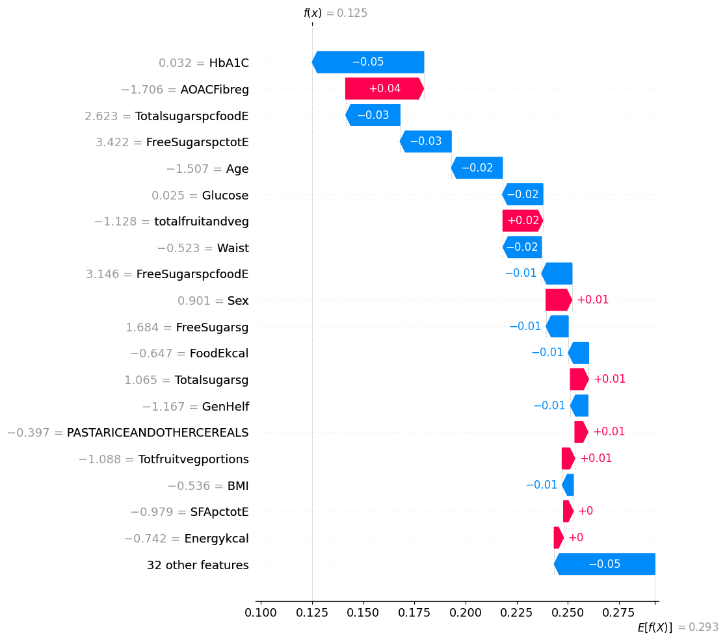
Figure 23 - Local SHAP values on positive diabetes prediction on row 9 using the random forest model at 40% oversampling ratio.
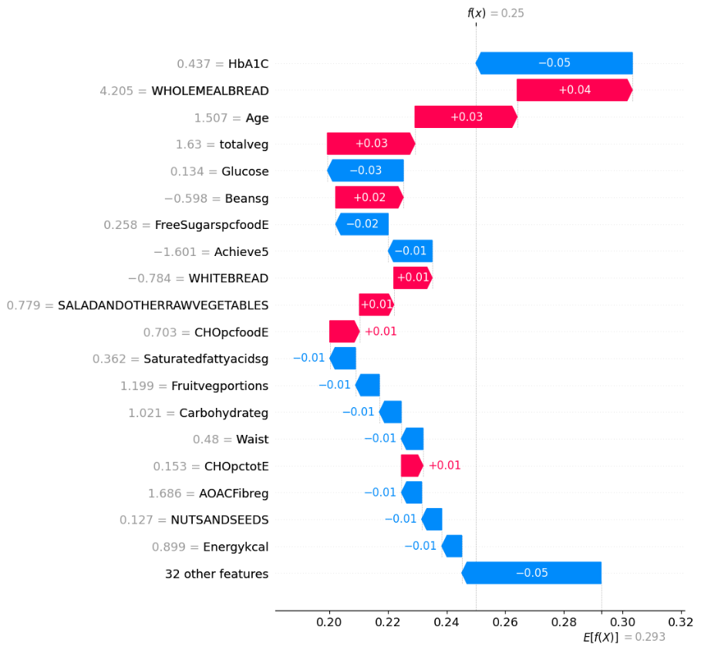
Figure 24 - Local SHAP values on positive diabetes prediction on row 54 using the random forest model at 40% oversampling ratio.

LIME
The last method that we will use is called Local Interpretable Model-agnostic Explanations or LIME. This gives us a better understanding of the specific features influence as it provides the thresholds that each feature met to make the diagnosis.
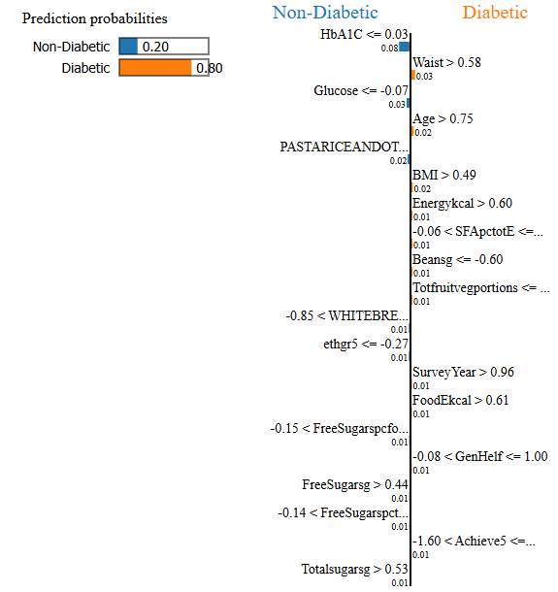
Figure 25 - LIME on positive diabetic prediction using random forest model with 40% oversampling ratio
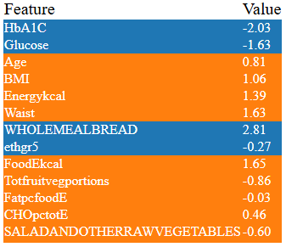
Table 7 - LIME results on positive diabetic prediction using random forest model with 40% oversampling ratio

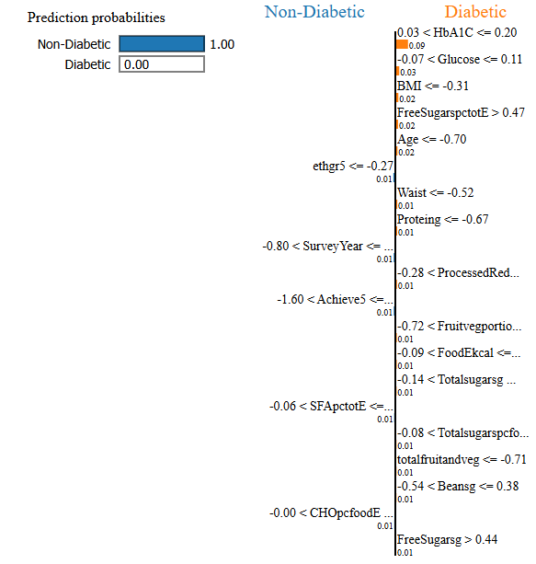
Figure 26 - LIME on negative diabetic prediction using random forest model with 40% oversampling ratio
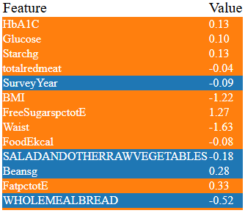
Table 8 - LIME results on positive diabetic prediction using random forest model with 40% oversampling ratio

References
[1] Public Health England (2025). National Diet and Nutrition Survey. GOV.UK. Available at: https://www.gov.uk/government/collections/national-diet-and-nutrition-survey.

[2] Lugner, M., Rawshani, A., Helleryd, E. and Eliasson, B. (2024). Identifying top ten predictors of type 2 diabetes through machine learning analysis of UK Biobank data. Scientific Reports. doi: https://doi.org/10.1038/s41598-024-52023-5.

[3] Islam, Md.M., Rahman, Md.J., Menhazul Abedin, Md., Ahammed, B., Ali, M., Ahmed, N.A.M.F. and Maniruzzaman, Md. (2022). Identification of the risk factors of type 2 diabetes and its prediction using machine learning techniques. Health Systems. doi: https://doi.org/10.1080/20476965.2022.2141141.
‌
[4] Ganie, S.M., Malik, M.B. and Arif, T. (2022). Performance analysis and prediction of type 2 diabetes mellitus based on lifestyle data using machine learning approaches. Journal of Diabetes & Metabolic Disorders. doi: https://doi.org/10.1007/s40200-022-00981-w.
‌
[5] Joshi, R.D. and Dhakal, C.K. (2021). Predicting Type 2 Diabetes Using Logistic Regression and Machine Learning Approaches. International Journal of Environmental Research and Public Health, 18(14). doi: https://doi.org/10.3390/ijerph18147346.
‌
[6] Farajollahi, B., Mehmannavaz, M., Mehrjoo, H., Moghbeli, F. and Sayadi, M.J. (2021). Diabetes Diagnosis Using Machine Learning. Frontiers in Health Informatics.
‌
[7] Katarya, R. and Jain, S. (2020). Comparison of Different Machine Learning Models for diabetes detection. [online] IEEE Xplore. doi: https://doi.org/10.1109/ICADEE51157.2020.9368899.

‌[8] Li, Z., Li, Y., Mao, Z., Wang, C., Hou, J., Zhao, J., Wang, J., Tian, Y. and Li, L. (2025). Machine Learning Models Integrating Dietary Indicators Improve the Prediction of Progression from Prediabetes to Type 2 Diabetes Mellitus. Nutrients, [online] 17(6). doi: https://doi.org/10.3390/nu17060947.
‌
[9] Goff, L.M. (2019) ‘Ethnicity and Type 2 diabetes in the UK’, Diabetic Medicine, 36(8). Available at: https://onlinelibrary.wiley.com/doi/full/10.1111/dme.13895?saml_referrer.

[10] Gholampour, Seifollah (2024) ‘Impact of Nature of Medical Data on Machine and Deep Learning for Imbalanced Datasets: Clinical Validity of SMOTE Is Questionable’, Machine Learning and Knowledge Extraction. Available at: https://doi.org/10.3390/make6020039.

